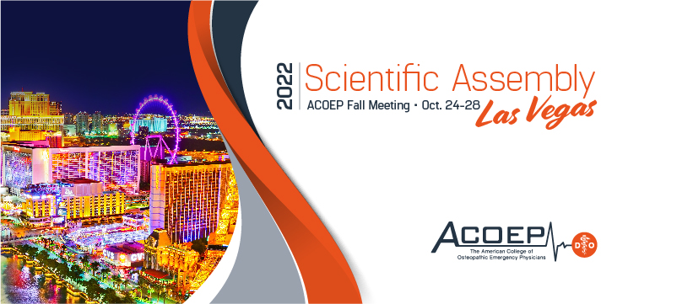
Schedule
At-a-glance**

Monday, October 24
8am – 4pm NAEMSP Foundations of Medical Oversight Course ($)*
8am – 12pm Resident and Student Labs
12pm – 4pm Student Leadership Academy ($)*

Tuesday, October 25
8am – 11am RSO Lecture Series - So You Think You Can Teach
8am – 11am General Sessions
11am – 12pm Keynote Speaker: Tracy Sanson
1pm – 6pm General Sessions
12pm – 2pm Resident Speed Dating ($)*
2pm – 4pm Resident Program Expo
6pm – 7pm Member Meeting
7:30pm – 9:30pm Welcome Reception

Wednesday, October 26
8am – 11am FOEM Research Competitions
8am – 11am General Sessions
11am – 12pm Keynote Speaker: Mizuho Morrison
12:15pm – 3:15pm NPIP Programming
1pm – 6pm General Sessions
1pm – 4:30pm FOEM Research Competitions
1:30pm – 3pm Simtastic 1 ($)*
5:30pm – 6pm Honors Ceremony
6pm – 10pm FOEM Gala ($)*

Thursday, October 27
8am – 12pm General Sessions
12pm – 2pm Panel Luncheon hosted by Women in EM Committee ($)*
1pm – 6pm General Sessions
1:30pm – 3pm Simtastic 2 (repeat of Simtastic 1) ($)*

Friday, October 28
8am – 4pm General Sessions

*additional fee; registration required
**schedule subject to change.

