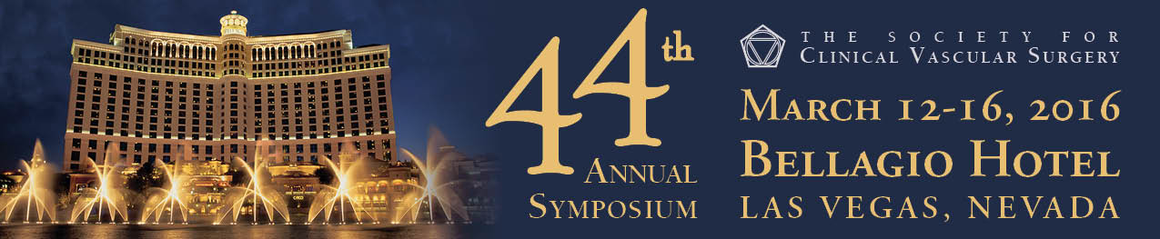
2016 Annual Symposium Registration Form

On-line registration available at: www.scvs.org
PLEASE PRINT OR TYPE INT OR TYPE

NAME: DEGREE:

NPI #:

INSTITUTION:

ADDRESS:

CITY: STATE/PROVINCE: ZIP: COUNTRY:

PHONE: FAX: EMAIL:
NAME OF SPOUSE / GUEST (only if registering):

ATTENDEE FEES | EARLY BIRD  (Through Feb. 14, 2015) | REGULAR FEE  (Beginning Feb. 15, 2015) | ONSITE FEE | QUANTITY
SCVS Member | $350 | $400 | $450
Guest Physician | $500 | $550 | $600
Resident/Fellow* | $150 | $200 | $250
Allied Health Professional | $250 | $250 | $300
Spouse/Guest** | $175 | $200 | $200
*With letter from Chief of Service
**Includes Welcome Reception, Annual Banquet & Continental Breakfasts
OPTIONAL SOCIAL ACTIVITIES/ADDITIONAL TICKETS

ANNUAL BANQUET, Tuesday, March 15, 2015 Adult (16+) $100 $ Child (5-15) $50 $
TOTAL FEES DUE $
PAYMENT METHOD___________________________________________________________________________ ___

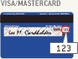
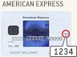
Fees payable via MasterCard, Visa, American Express or check drawn on a US bank.

□ Check Enclosed
Please make checks payable to SCVS
Security Code: (See card images above)

CREDIT CARD NUMBER: EXPIRATION DATE: /
Billing ADDRESS:
(If not the same as address listed above)
SIGNATURE: ________________________________________________
I authorize SCVS to charge my credit card the above fees.

CANCELLATION POLICY: Cancellations cannot be made via the on-line website, but must be made in writing to the SCVS Administrative Offices. Direct your correspondence to: SCVS, 500 Cummings Center, Suite 4550, Beverly, MA 01915. If written notice of cancellation is received at the SCVS Administrative Offices on or before March 4, 2016, the registration fee, less a $50 USD administrative fee, will be refunded after the meeting. No refunds will be issued for cancellations received after March 4th. Fees cannot be reduced for partial attendance.

