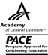
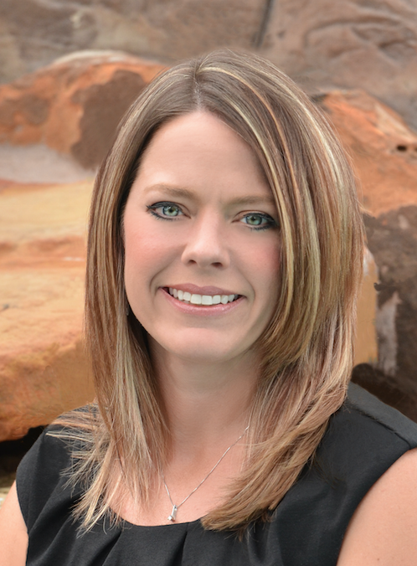
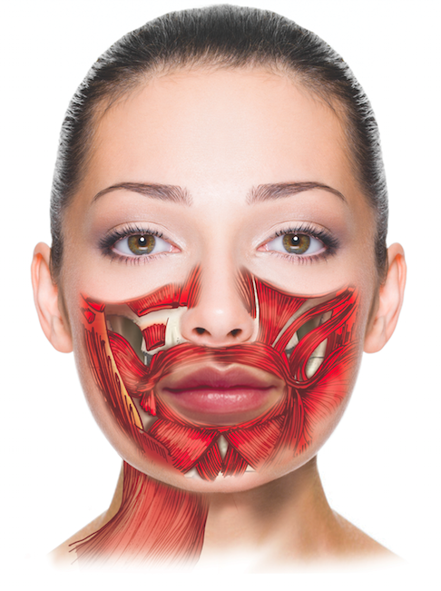

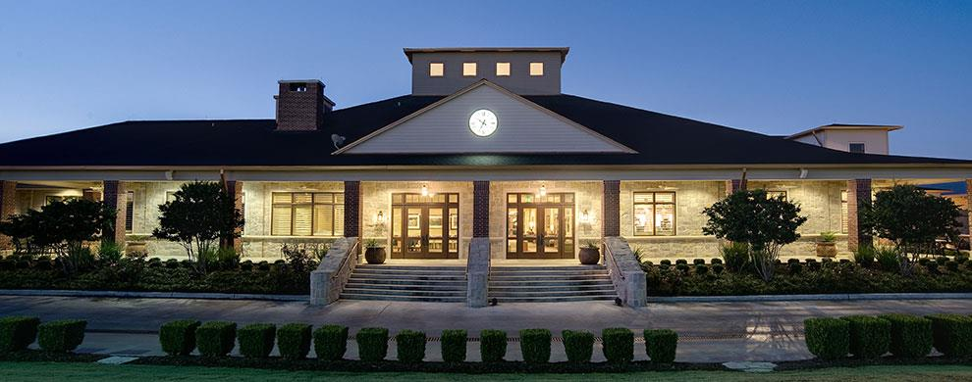
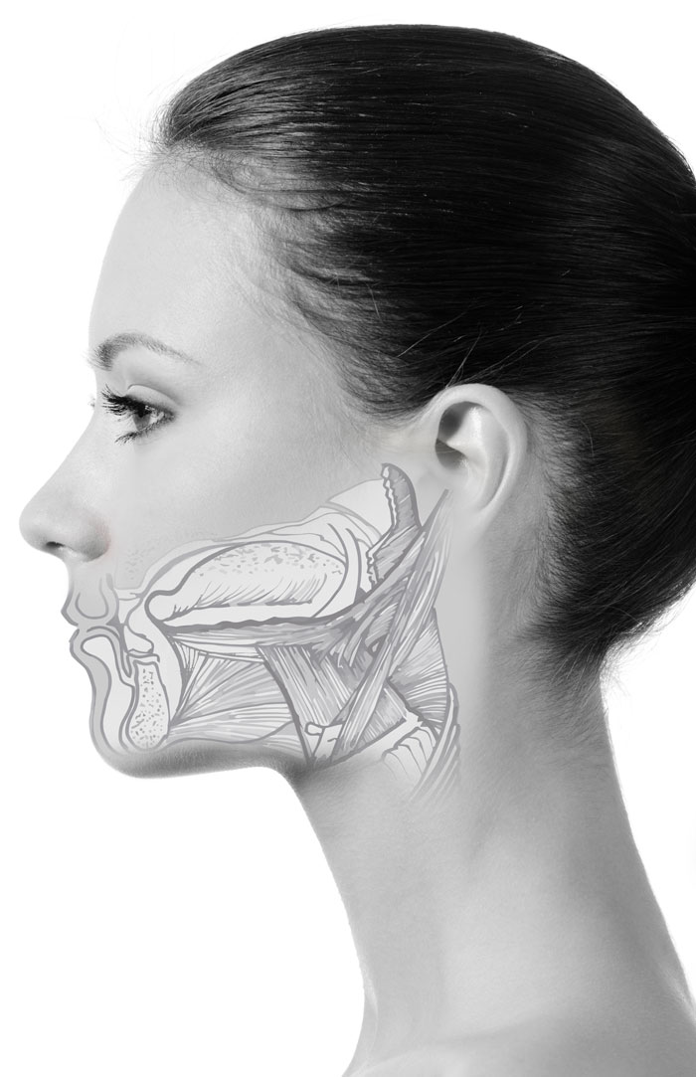
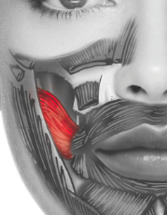
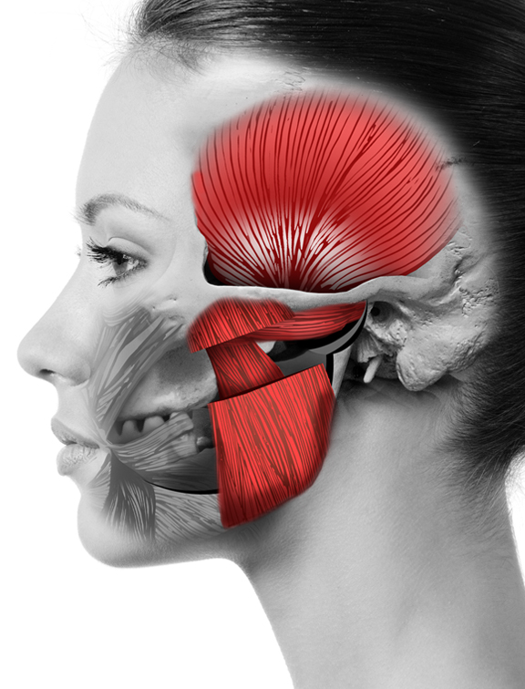
This program is offered for 2.8 CEUs (Introductory level, Professional area)
This course provides the participant with a comprehensive understanding of the foundations in orofacial myology. Parameters include developmental anatomy/physiology, dental, speech, medical etiologies, diagnostics, treatment planning, habit elimination, ethical scope of practice considerations and the didactic interaction of the orofacial complex from birth.
SLC@Home
16531 Chalk Maple Lane, Houston, Texas 77095
Kristie@slchouston.com
Kristie Gatto, MA, CCC-SLP, COM
2016 Course Dates:
June 23-26, 2016
July 14-17, 2016
November 10-13, 2016

Course Description
A 4-day, 28-hour (2.8) Comprehensive Introductory course to
Orofacial Myology
Kristie Gatto, MA, CCC-SLP, COM received her bachelor’s and master’s degrees from the University of Houston in Houston, Texas. In 2004, Ms. Gatto became the co-owner of a private practice in Northwest Houston and began her journey in treating children with pediatric feeding disorders. After years of searching for answers in traditional feeding approaches, she underwent training in the field of Orofacial Myology and became the first certified orofacial myologist in the city of Houston in 2011. Ms. Gatto is currently the owner of The Speech and Language Connection, which has two offices in the greater Houston area and employs 24 speech-language pathologists with various specialties.

Ms. Gatto is a member of the American Speech-Language-Hearing Association (ASHA), International Association of Orofacial Myology (IAOM), and American Academy of Private Practice in Speech Pathology & Audiology (AAPPSPA), Texas Speech-Language-Hearing Association (TSHA), and Houston Association for Communication Disorders (HACD). Additionally, she serves on the board of directors for the IAOM and AAPPSPA and the Community Advisory Board for the University of Houston.

Speaker: Kristie Gatto, MA, CCC-SLP, COM

Understanding the Orofacial Complex
  - Kristie Gatto, MA, CCC-SLP, COM
To register, please contact: Kristie@slchouston.com
281.682.2659
281.798.5679

Registration Fee: Please call for fees

Includes:
Understanding the Orofacial Complex: Text
Muscle Manual
Handouts and sample forms
Treatment supplies

Financial disclosures: Ms. Gatto receives monetary fees for speaking. Additionally, materials provided consist of books that were created as a for-profit means.
Non-Financial disclosures: Ms. Gatto is the President-Elect for the IAOM, on the Board of directors for AAPPSPA and the Community Advisory Board at the University of Houston.
Day 4
Comprehensive Assessment
Evaluation Summary (Q&A)
Therapeutic exercises
Habituation
Speech Patterns
Documentation
Business Management
Day 2
Physiology of the Swallow
Anomalies of the craniofacial structures
Comprehensive Case History
Comprehensive Assessment
Photography in assessment
Day 1
IAOM History and Background
Certification Information
Scope of Practice and Ethical considerations
Embryology and Facial Development
Hard and soft tissues of the Orofacial Complex
Dentition

Registration information:
Coursework will be taught:
14500 Houston National Blvd
Houston, Texas 77095
Kristie is an amazing teacher who takes her time to present the information in a very concise but simple way to understand. She is open to questions and really is attune to the student’s needs and levels of learning.
Day 3
Treatment Hierarchies
Photography in treatment
Universal Precautions
Application of the Hierarchy
Non-nutritive sucking habits
Wendy Agero, MS, CCC-SLP

