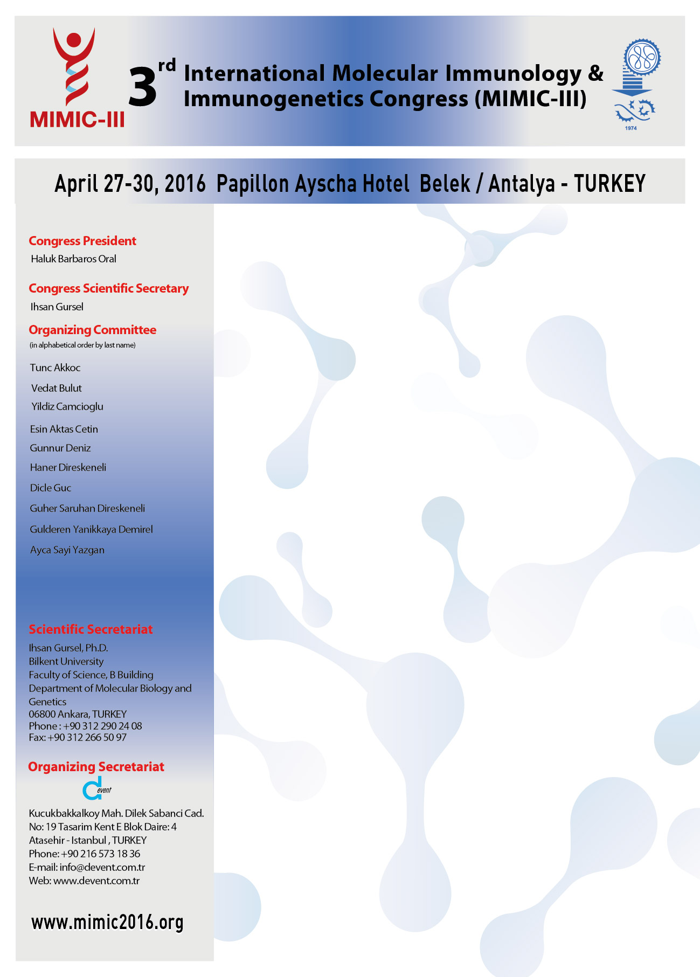
Account Name | Devent Turizm Org. Hizmetleri
Bank Name and Branch | Garanti Bank (Atasehir - 391)
TL Account Number | 6295631
TL IBAN Number | TR37 0006 2000 3910 0006 2956 31
EURO Account Number | 9079069
EURO IBAN Number | TR95 0006 2000 3910 0009 0790 69

REGISTRATION AND ACCOMMODATION FORM
Please PRINT in BLOCK LETTERS Email to: info@mimic2016.org

Name Surname :
Title : □ Prof. □ Dr. □ Mr. □ Mrs. □ Ms.

Instution /University :

City - Country :

E-Mail :

Mobile Phone :

Registration Fees Before April 1st, 2016 As from April 2nd, 2016

□ Specialist, Industry 100 - EU 150 - EU

□ Assistant, Student 50 - EU 100 - EU

□ Specialist*, Industry* 200 - EU 250 - EU

□ Assistant*, Student* 150 - EU 200 - EU

□ Daily Participation 100 - EU

* For those who do not stay in the Congress Hotel

Accommodation Package Fees Before April 1st, 201As from April 2nd, 2016
□ Single Room 390 - EU 450 - EU
□ in Double Room Per Person 290 - EU 340 - EU

Accommodation Package Fees Includues:
- Accommodation in Papillon Ayscha Hotel for 3 nights
- (Check-in 27 April, Check-out 30 April)
- Package Fees are in “All Inclusive” basis

Transfer Fee □ € 100 Airport – Hotel - Airport

18 % VAT will be added to the above mentioned fees.
- Master and Visa Card is acceptable and 1,5% Bank Commission will be added to grand total. AMEX is not acceptable.
- Bank transfer details are below

MAIL ORDER FORM
Credit Card Authorization Form

Card Owner’s Name Surname :

Credit Card Bank Name :
Mobile Phone – Land Line :

Address :

Billing Information :

Card Number (Write your 16-digit credit card number)
__ __ __ __ / __ __ __ __ / __ __ __ __ / __ __ __ __

Expiry Date of Credit Card (Month / Year)
__ __ / __ __

Security Code (CVV2) □ Master Card □ Visa Card
__ __ __

Payment Amount (in Numbers) Payment Amount (in Writing)
_____________________ _________________________________________

Payment Date
__ __ / __ __ / __ __ __ __

Name Surname Signature

