The 102nd Pacific Coast Oto-Ophthalmological Society Meeting
Meeting Registration Form June 22-24, 2018
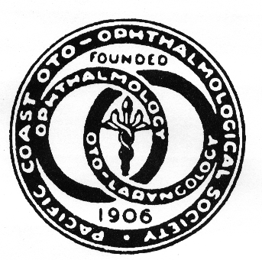  Additional Meals:  CONTINENTAL BREAKFAST  Friday, June 22 (1 Ticket included with registration)  Additional Tickets:  Adults $31 .. #_______ $________  Child: $16 (5-11yrs) #_______ $________  Saturday, June 23 (1 Ticket included with registration)  Additional Tickets:  Adult: $31 #_______ $_______  Child $16 ($5-ll yrs) #_______ $_______  Sunday, June 24 (1 Ticket included with registration)  Additional Tickets:  Adults $31 #_______ $________  Child: $16 (5-11yrs) #_______ $________  PRESIDENT’S Welcome Reception - Included  Friday, June 22 (1 Ticket included with meeting Registration).  *Please check if you plan to attend ___________  Additional Tickets:  Adult : $55 # _______ $__________  Child: $30 (5—11yrs) # _______ $ _________  Children under 5 are free only if registered in advance  On-site under age 5 fee is $20  Guest Names:______________________________  Badges must be worn at all times  Please indicate any dietary restrictions:  _______________________________  *Meeting Cancellation: Refund minus $65 provided if cancellation is received in writing by May 15, 2018 | REGISTRATION  Please Print  Registration includes:  Continental Breakfast and Refreshment Breaks Daily and  Friday Reception  Meeting Registration (above) $ _____________  Meals (left side) $ _____________  Membership Renewal (above) $ _____________  TOTAL $ _____________  Please pay usimg Paypal . Credit cards are Accepted.
  NAME
  ADDRESS
  CITY STATE ZIP
  PHONE:
  E-MAIL (required – please print clearly)
  ACADEMIC AFFILIATION or COMPANY
  Ophthalmology _or Otolaryngology ____
  REGISTRATION | By  2/15/18 | By  4/15/18 | By  6/15/18 | On-Site
  PCOOS MEMBER  (Active/Senior) | $589 | $639 | $689 | $719
  NON-MEMBER PHYSICIAN | $769 | $819 | $859 | $879
  RESIDENT/FELLOW | $279 | $319 | $349 | $369
  Corporate Attendee | $1,150 | $1,250 | $1,295 | $1,325
  MEMBERSHIP RENEWAL | $149 | $149 | $169 | $179
  NEW MEMBERSHIP | $99 | $99 | $99 | $99

PACIFIC COAST
OTO-OPHTHALMOLOGICAL SOCIETY
- 17th Avenue
San Francisco, CA 94122
Email: Thelma.PCOOS@gmail.com; Website: WWW.PCOOSonline.org
Thelma de Souza, Society Manager, Phone: (415) 269-0089

2017 MEMBERSHIP DUES STATEMENT

ANNUAL DUES ...........................................................$ 149

ANNUAL DUES New Member ................................$ 99
Age 65 and Retired.........................................................$ 25 (Optional)
RETIRED and over 70……………………………...…Complimentary
Residents and Fellows .................................................. Complimentary
(Donations appreciated: Non-profit TAX ID #95-6059535)
*Add $20 if dues not received by 4/15/17

OPH___ OTO____ Sub-Specialty:______________________________

Name of Member : _____________________________________________________________

Affiliation: ___________________________________________________

Email (required):______________________________________________

Phone:__________________

Current Mailing Address: _______________________________________________________
_______________________________________________________ _______________________________________________________

Would you like to be listed in the PCOOS Directory? ___ YES ___ NO

Amount $_______________

Signature:_________________________________________________________

Make check payable to: Pacific Coast Oto-Ophthalmological
Mail to: Thelma de Souza, 1681 17th Avenue, San Francisco, CA 94122

THANK YOU - WE APPRECIATE YOUR SUPPORT!

