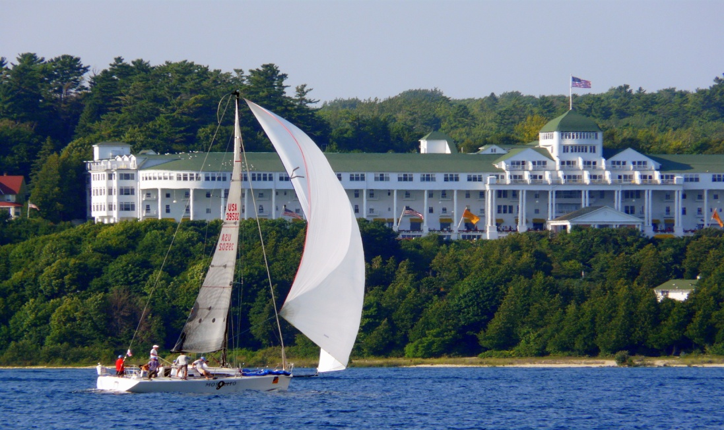
MICHIGAN ORTHOPAEDIC SOCIETY 55th ANNUAL SCIENTIFIC MEETING
PROGRAM REGISTRATION FORM
JUNE 19-21, 2015 (Friday, Saturday, Sunday), The Grand Hotel, Mackinac Is.
Keynote Speakers: Charles Bush-Joseph, MD
Brian Springer, MD

Name: _______________________________________________________________________________
Office Address: ________________________________________________________________________
City: __________________________State:_______Zip Code:________
Office Phone: ___________________________Email:________________________________________
(We do email blasts for program events and legislative updates.)
REGISTRATION FEES:

MOS Member No charge with 2015 dues paid or Emeritus status

Orthopaedic Resident & Fellow No charge

Presenter No charge (Podium or Poster presenter)

PA-C, NP, PT, ATC, MA $50

Office Manager or Staff $30 Nonmember Physician $350

Dr. J. David Blaha, Program Director, has assembled an impressive educational program for the Friday afternoon, June 19 didactic sessions. Many areas of specialty including trauma, foot and ankle, shoulder and hip will be covered in the afternoon program. BE SURE AND REGISTER FOR HOTEL BY MAY 18. Hotel form must be faxed to the Grand Hotel. (See top of form, upper left hand corner for fax number.) Form will also be online at www.mosonline.org More info on the reverse side>>>>>

SOCIAL EVENTS: Friday evening reception will be held in the Grand Pavilion overlooking the golf course. The Saturday evening reception will be on the East Front Porch of the Grand Hotel.

Golf Event: Saturday afternoon, June 20 at the Jewel course. You must contact the Grand Hotel pro shop to charge your golf to your credit card in advance or to your hotel room at 1-800-33-GRAND. Mention the MOS Annual Scientific Meeting.

MAIL THIS REGISTRATION FORM TO: Pam Dietrich, MOS, P.O. Box 475, Northville, MI 48167.

Questions: (734) 646-3720 or check events online at www.mosonline.org

Our plan for great podium presentations, category 1 CME applied for, gala events, time to reconnect with colleagues and perfect weather will make this the annual meeting you do not want to miss!

William Higginbotham, MD, President and Pam Dietrich, Executive Director

